# **Mono-alphabetic Ciphers**

# **Poly-alphabetic Ciphers**

# **Caesar Ciphers**

# **Playfair Ciphers**

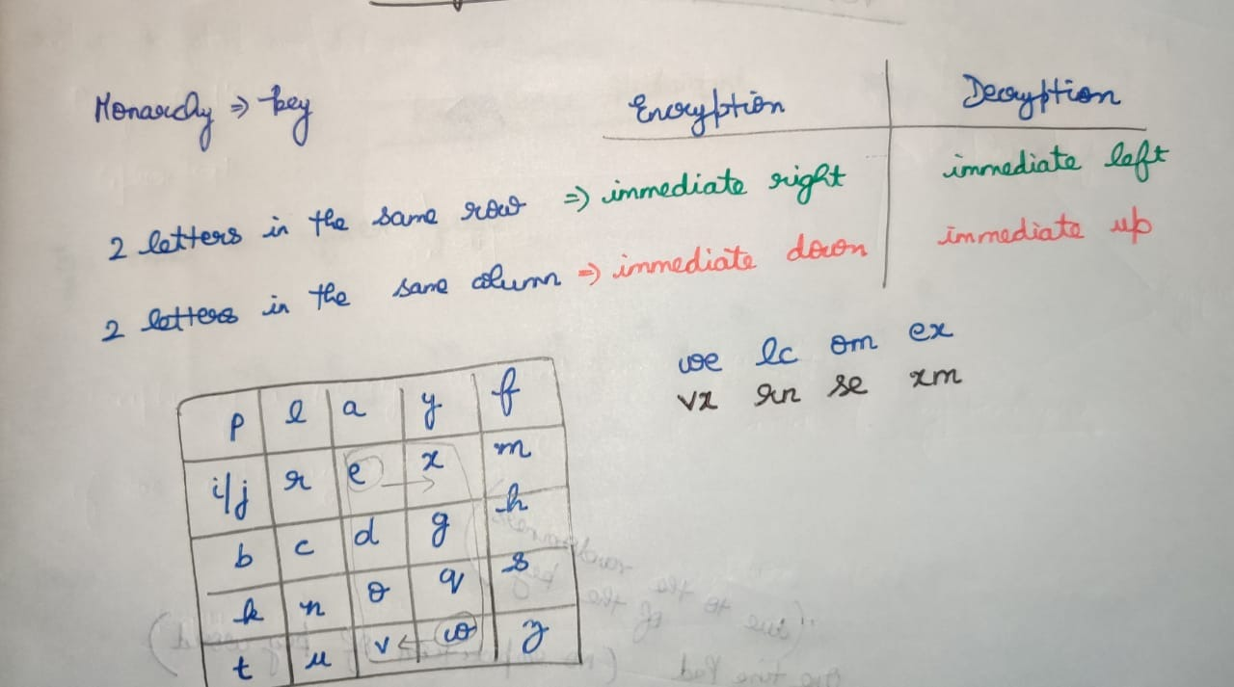

# **Polyalphabetic Cipher**

## **Vigenere Cipher**

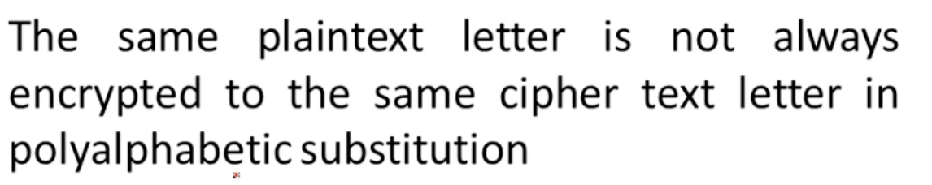

**Using Vigenere 26*26 table**

Plain text along row and Key along column

Where the key and plain-text intersect 🡪 Cipher text

Encryption

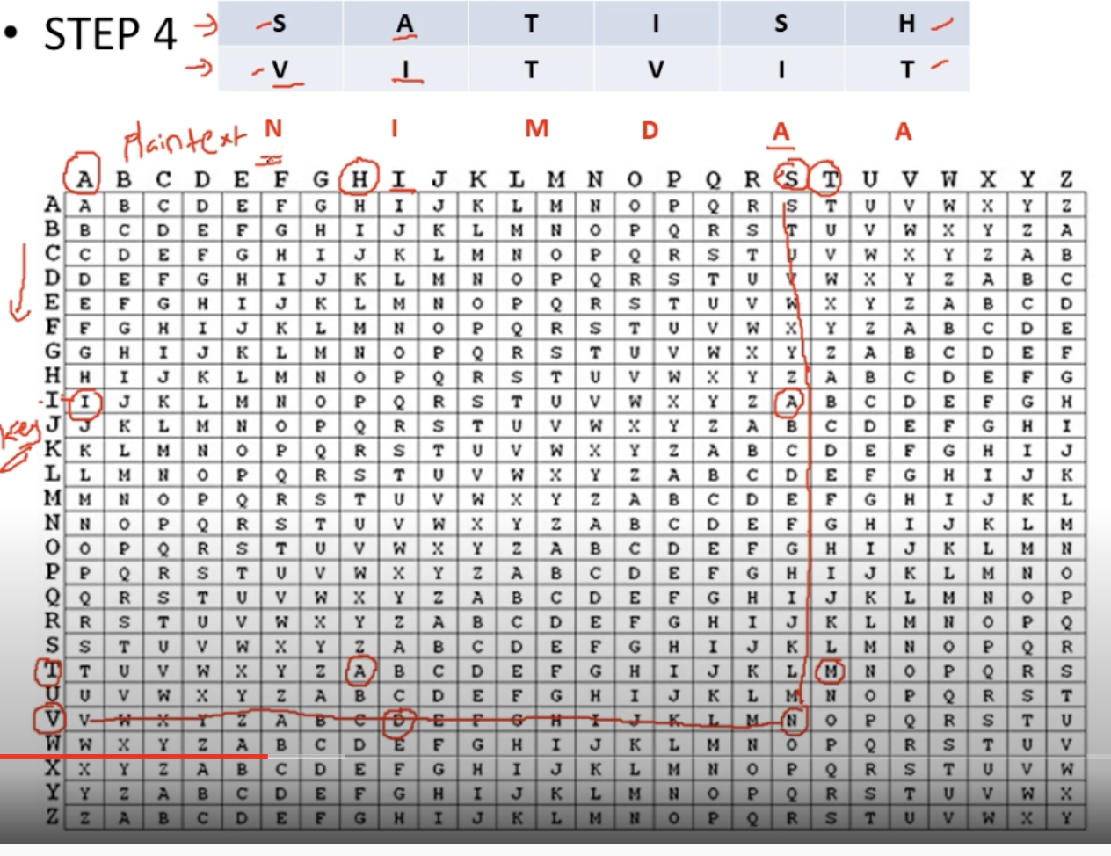

Decryption

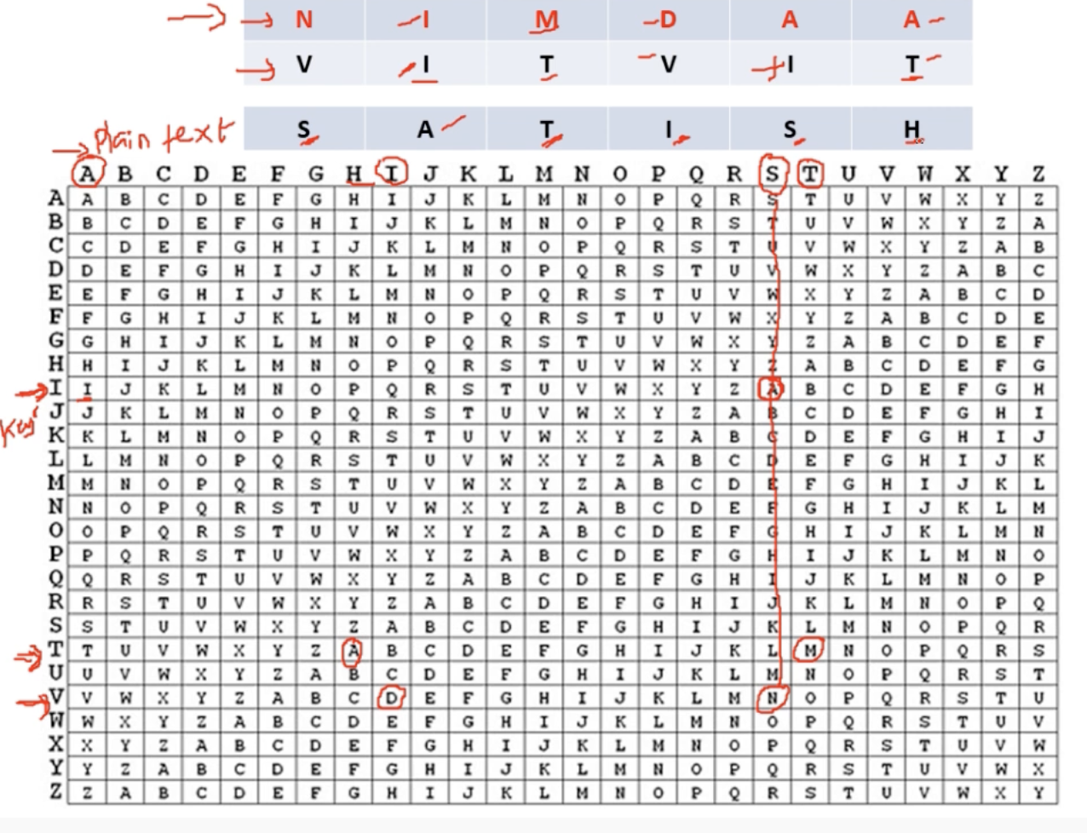

**Algebraic Representation of Vigenere Cipher**

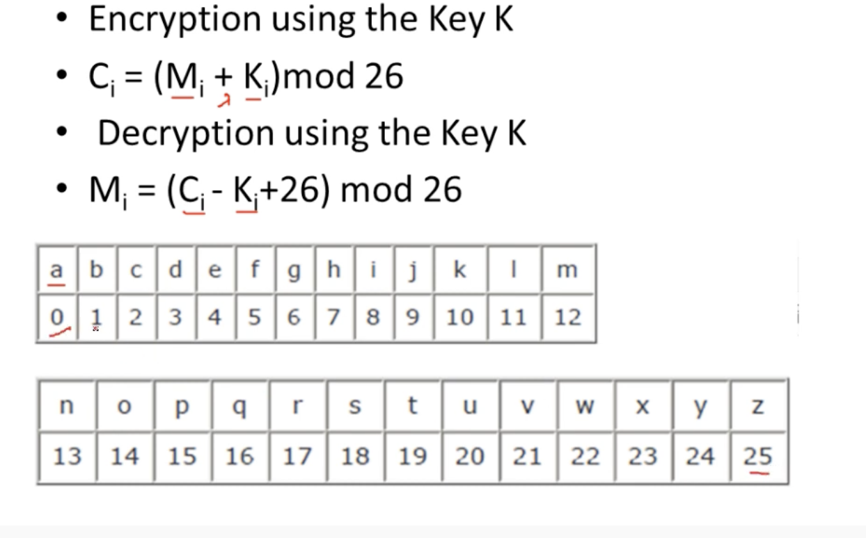

Encryption

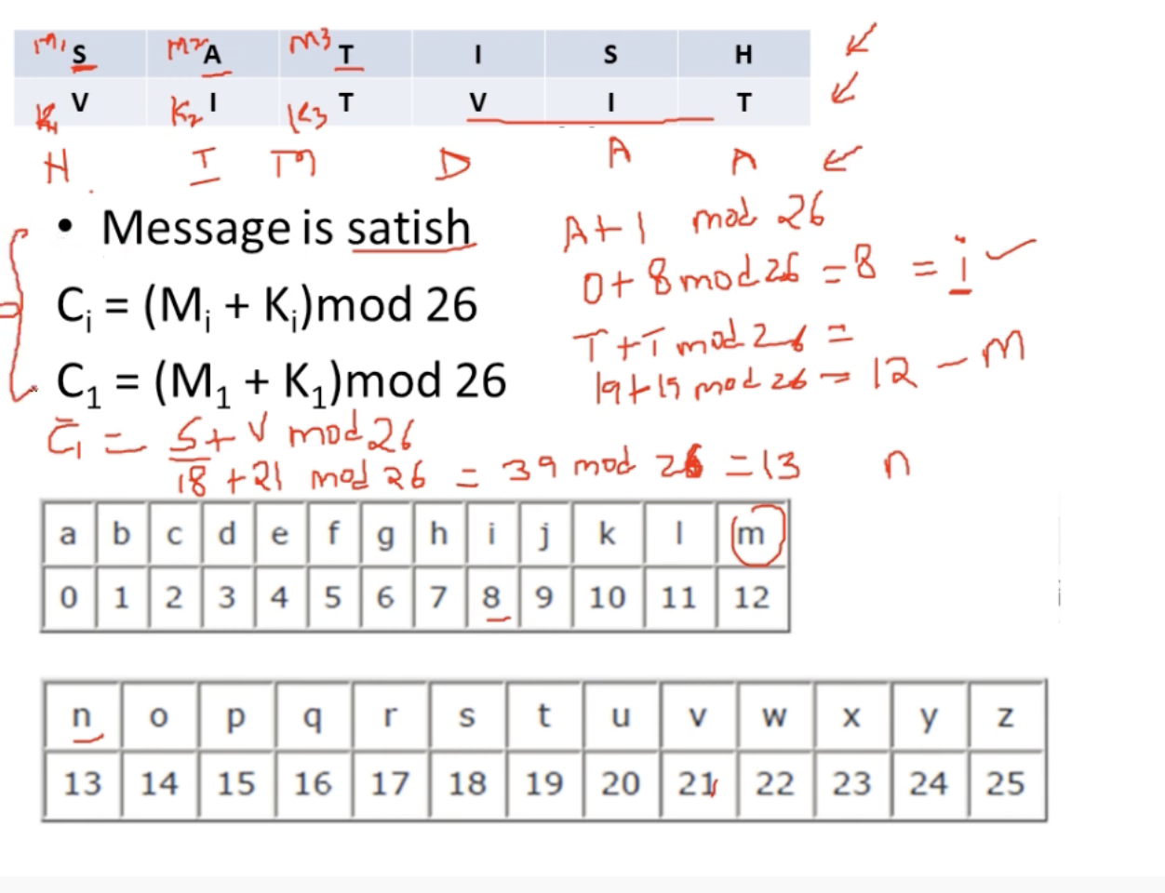

Decryption  
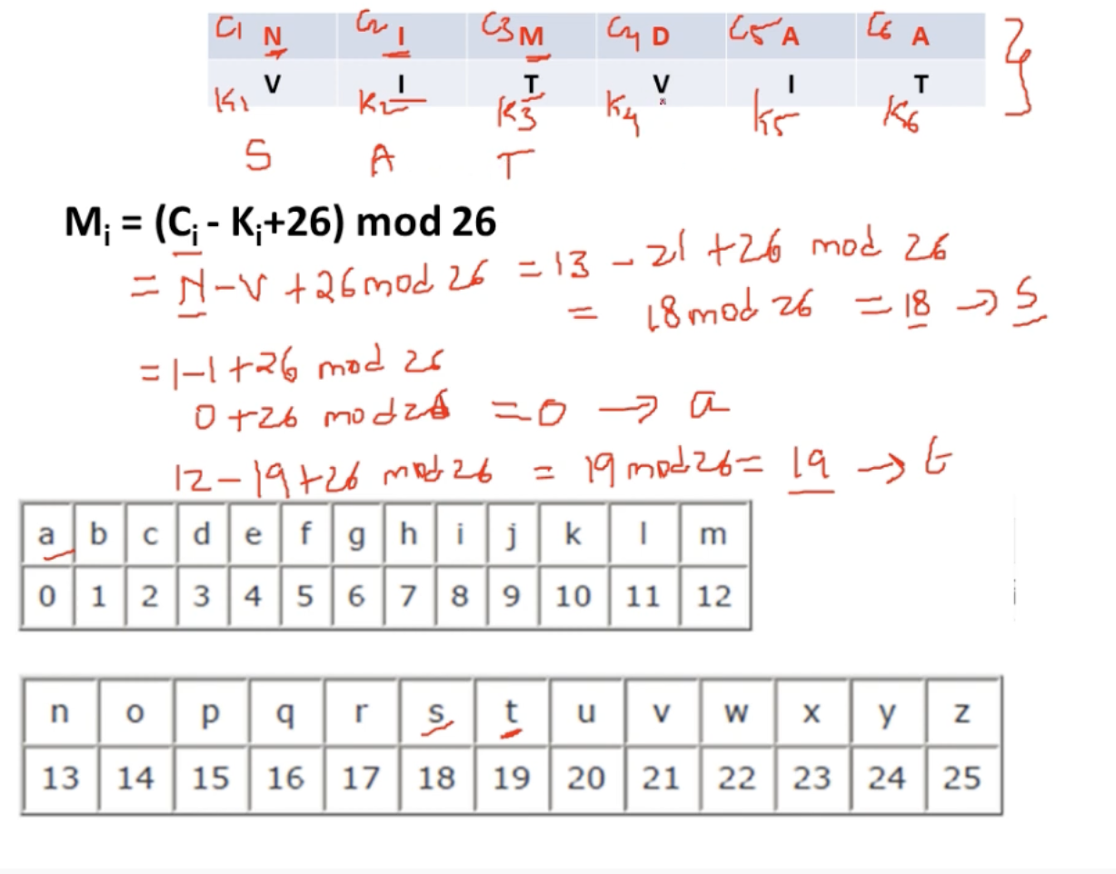

### **Eg-1**

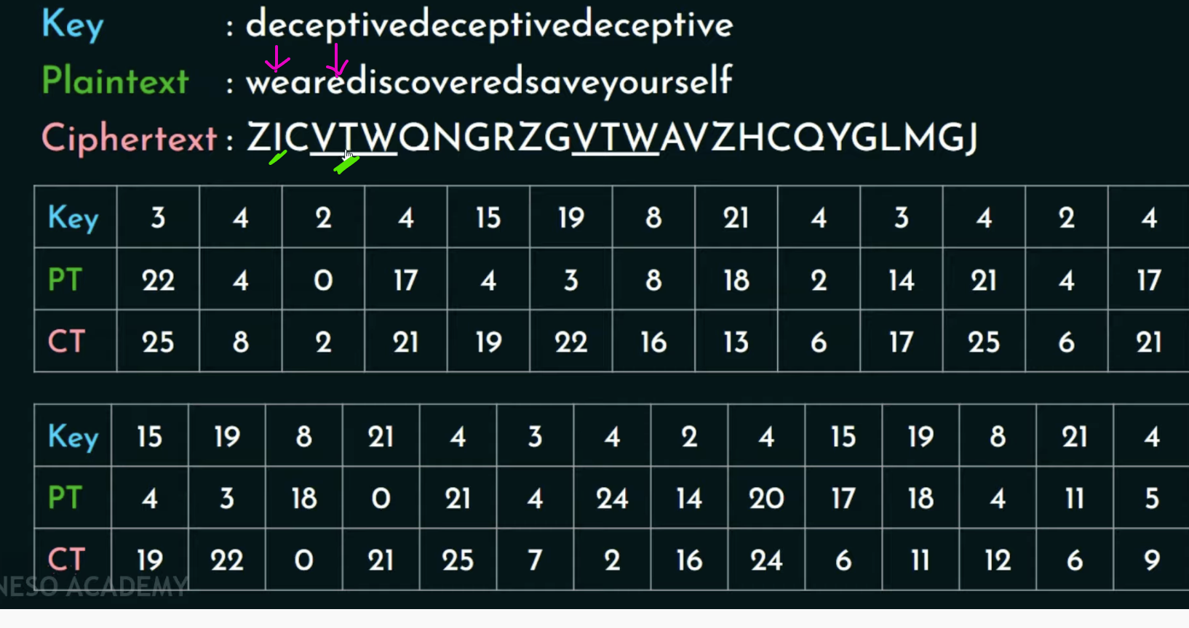For a same plain-text we cannot except the exact cipher text.  
one e 🡪 i  
another e 🡪 t

This is the reason why Vigenere Cipher is Polyalphabetic Cipher

# **Hill Cipher**

# **References**

<https://www.youtube.com/watch?v=9Q72dBsNIx8&list=PLqfPEK2RTgCgJhjoDrmUYY7R0mzJzw9Mu&index=21&t=152s>

<https://www.youtube.com/watch?v=Ic4BzVggNY8>